LAB Logbook

Lab 1
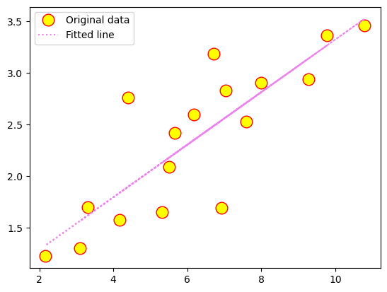
Lab 2
Test Accuracy: 0.901

Model: "sequential_1"
_________________________________________________________________
Layer (type) Output Shape Param #
=================================================================
dense_4 (Dense) (None, 64) 704

dense_5 (Dense) (None, 32) 2080

dense_6 (Dense) (None, 1) 33

=================================================================
Total params: 2817 (11.00 KB)
Trainable params: 2817 (11.00 KB)
Non-trainable params: 0 (0.00 Byte)
_________________________________________________________________
None
Model: "sequential_1"
_________________________________________________________________
Layer (type) Output Shape Param #
=================================================================
dense_4 (Dense) (None, 64) 704

dense_5 (Dense) (None, 32) 2080

dense_6 (Dense) (None, 1) 33

=================================================================
Total params: 2817 (11.00 KB)
Trainable params: 2817 (11.00 KB)
Non-trainable params: 0 (0.00 Byte)
_________________________________________________________________
None

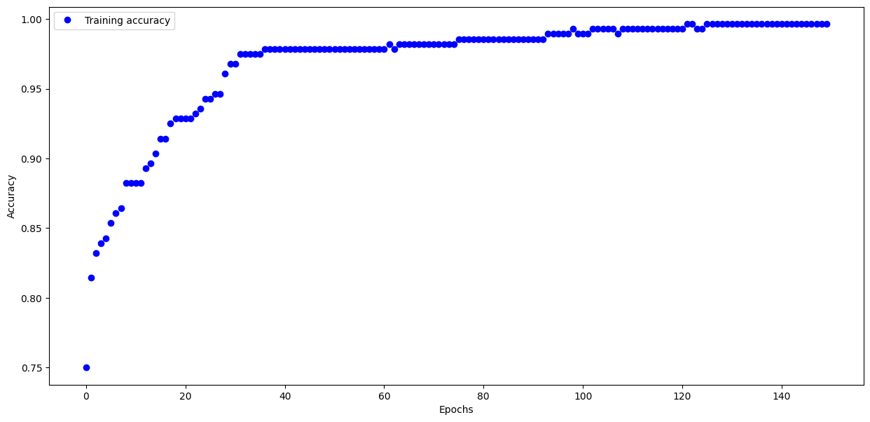
Task 2 :
O1 : 0.823
O2 : 0.823

Lab 3

Lab 4

Lab 5

Lab 6

Lab 7

Lab 8

Lab 9

Lab 10

Lab 11

Lab 12

